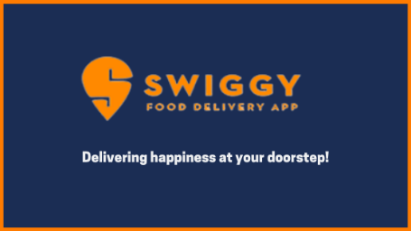

**Introduction**

Swiggy is an online food ordering platform. It connects people with restaurants. People can use Swiggy app or website to look for eateries around their area and order food from them. Swiggy has a team of delivery executives who pick up the order from the restaurants and deliver it to the address provided by the customer.

Started in **2014** by **Nandan Reddy, Sriharsha Majety, and Rahul Jaimini**, it expanded exponentially, and it now has over **40,000 restaurant partners** spread over more than **44 cities in the country**.

**Marketing Strategies**

### ****Discounts and Promotions:** Swiggy often offers discounts, cashback offers, and promo codes to attract and retain customers. These promotions are frequently used to incentivize first-time users and encourage repeat orders.**

### ****Referral Programs:** Swiggy has implemented referral programs where existing customers can refer friends and family to the platform in exchange for rewards or discounts on future orders. This strategy leverages word-of-mouth marketing.**

### ****Partnerships and Tie-ups:** Swiggy partners with various restaurants and eateries to offer a wide range of food options to its customers. These partnerships help in expanding their menu and attracting a diverse customer base.**

### ****Swiggy Super:** Swiggy Super is a subscription-based loyalty program that offers benefits such as free deliveries, exclusive discounts, and faster delivery times to its members. This program encourages customer retention and higher order frequency.**

### ****Targeted Advertising:** Swiggy uses data-driven advertising to target specific user segments with personalized promotions and recommendations. They send emails and push notifications to users based on their ordering history and preferences.**

### ****Social Media Marketing:** Swiggy maintains an active presence on social media platforms like Facebook, Instagram, Twitter, and YouTube. They use these platforms to engage with customers, share food-related content, and run advertising campaigns.**

### ****Innovative Campaigns:** Swiggy occasionally runs creative marketing campaigns and contests on social media to generate buzz and engage with customers. For example, they have run campaigns like #SwiggyVoiceofHunger and #SwiggyStarHunt.**

### ****Localized Marketing:** Swiggy tailors its marketing efforts to specific cities and regions, understanding the local food culture and preferences to better connect with the target audience.**

### ****Customer Feedback and Improvement:** Swiggy actively seeks feedback from customers through its app and website. They use this feedback to make improvements in their service and address customer concerns, demonstrating a commitment to customer satisfaction.**

### ****Sponsorships and Events:** Swiggy has sponsored events and partnered with popular sports leagues and tournaments to increase brand visibility and reach a broader audience.**